105 Lt. Michael Cleary Dr, Dallas, PA 18612

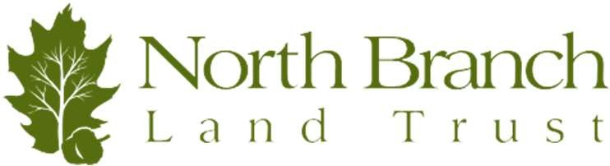

Phone: (570) 310-1781 · Fax: (570) 310-1791

[info@nblt.org](mailto:info@nblt.org) · [**www.nblt.org**](http://www.nblt.org/)



**AUCTION DONATION FORM**

Donor Information

Contact Name Company Name Address

Phone Number

Contact Person (If different than donor name)

Contact Email Contact Phone (Daytime)

How will NBLT receive your donated auction item?

* I will drop off during NBLT office hours on __/__/__
* I will call/email to coordinate pickup
* I will bring it to the event on 4/30/25
* Intangible/Experiential – I have a brochure, ad, or postcard with information
* Intangible/Experiential – Please make an item card with information provided

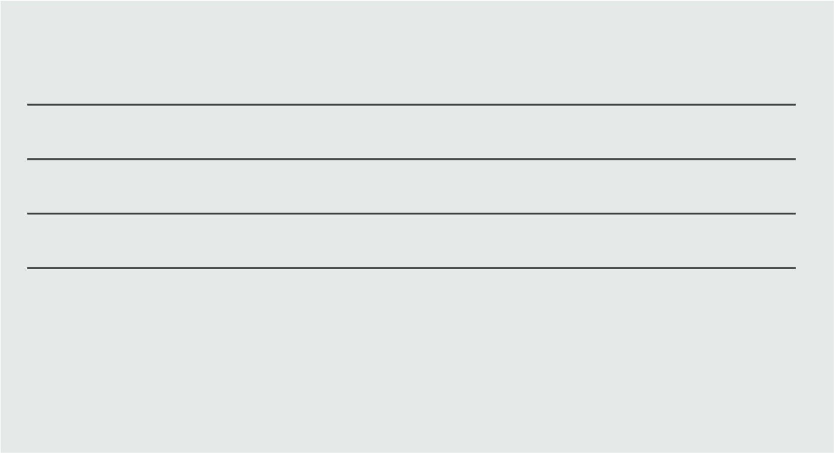

**Auction Item Information**

please send photograph of item to info@nblt.org